DA Assignment – 3

Visualizations using Tableau Public

Name: Tupakula Shaik Sameer

College: NRI INSTITUTE OF TECHNOLOGY-VISADALA

Chart 1 : Bar chart – Total Sales by City

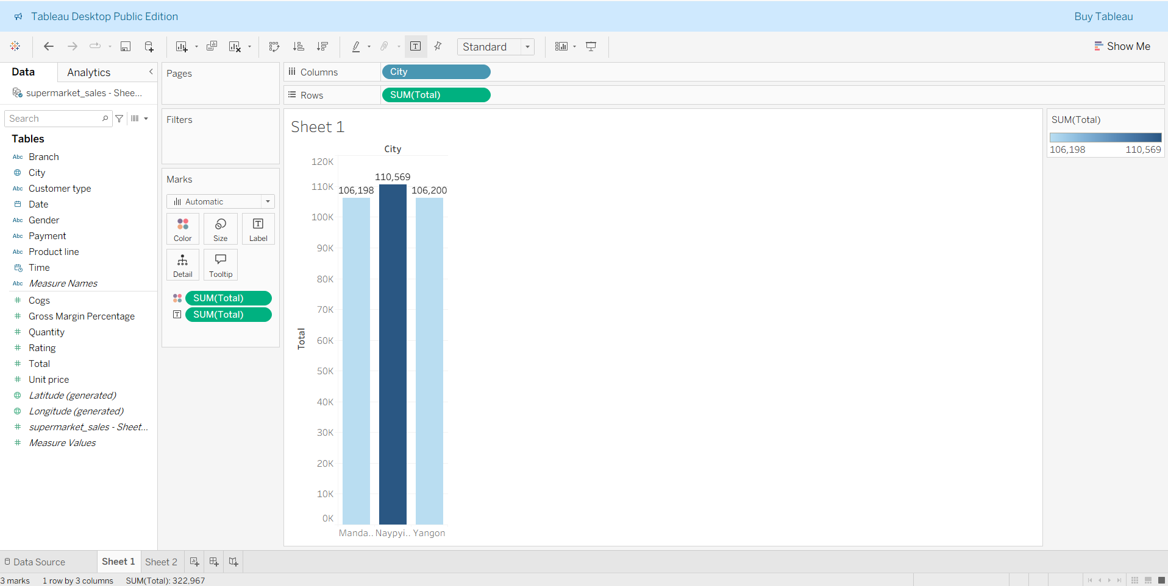

# 

# Chart 2 : Product Lines by Sales

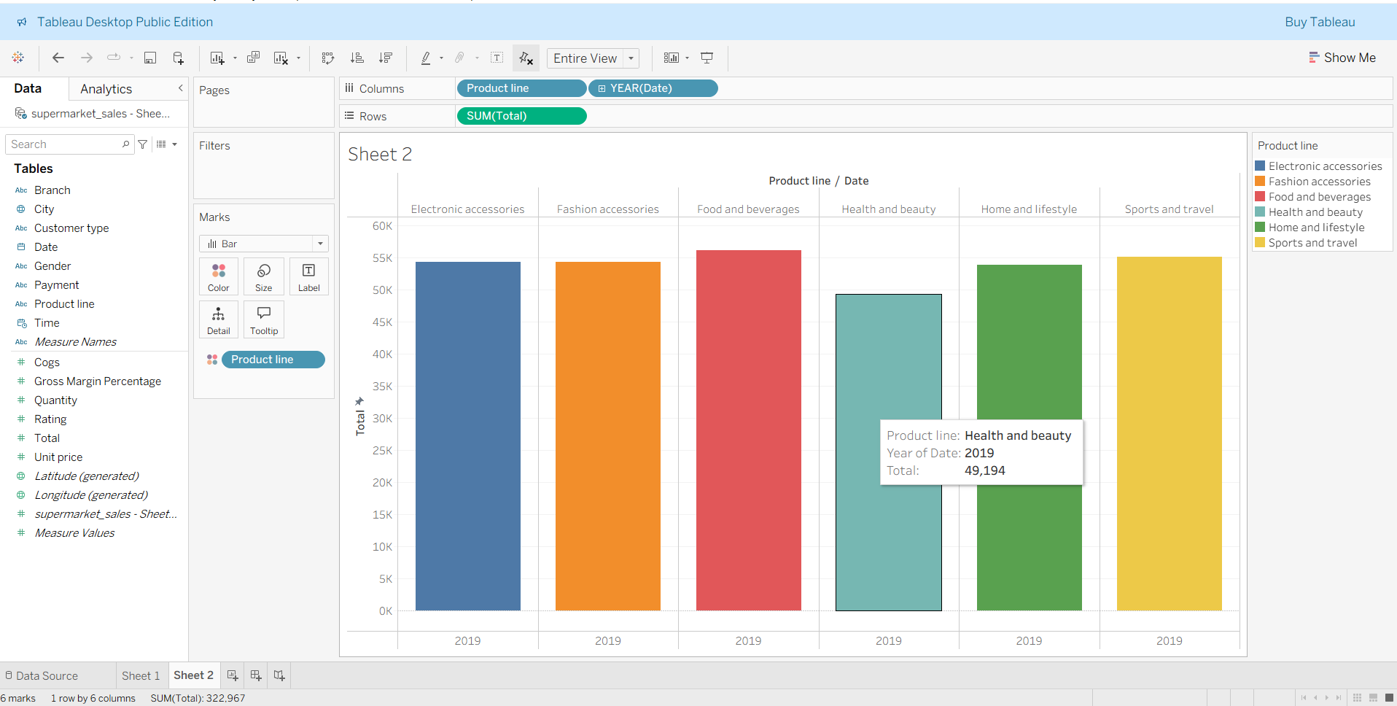

# Chart 3 : Payment Method Distribution how customers pay ( Cash, Credit Card, etc.)

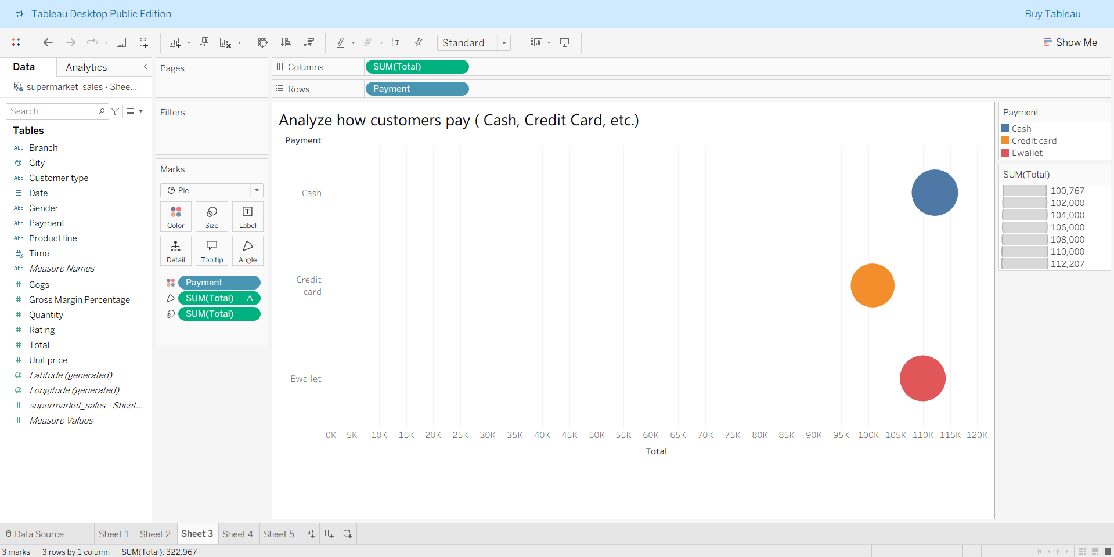

# Chart 4 :Branch-wise Performance Compare total revenue across supermarket branches (A, B, C).

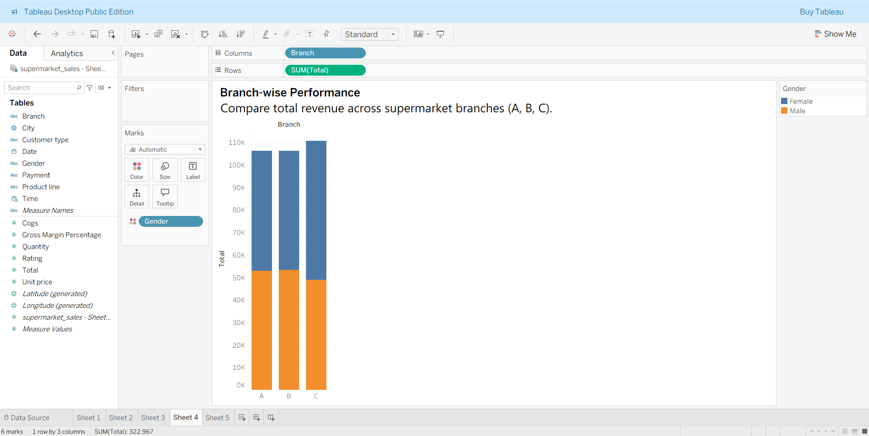

# Chart 5 : Create a dual-line chart to show Total Sales vs Quantity over Time

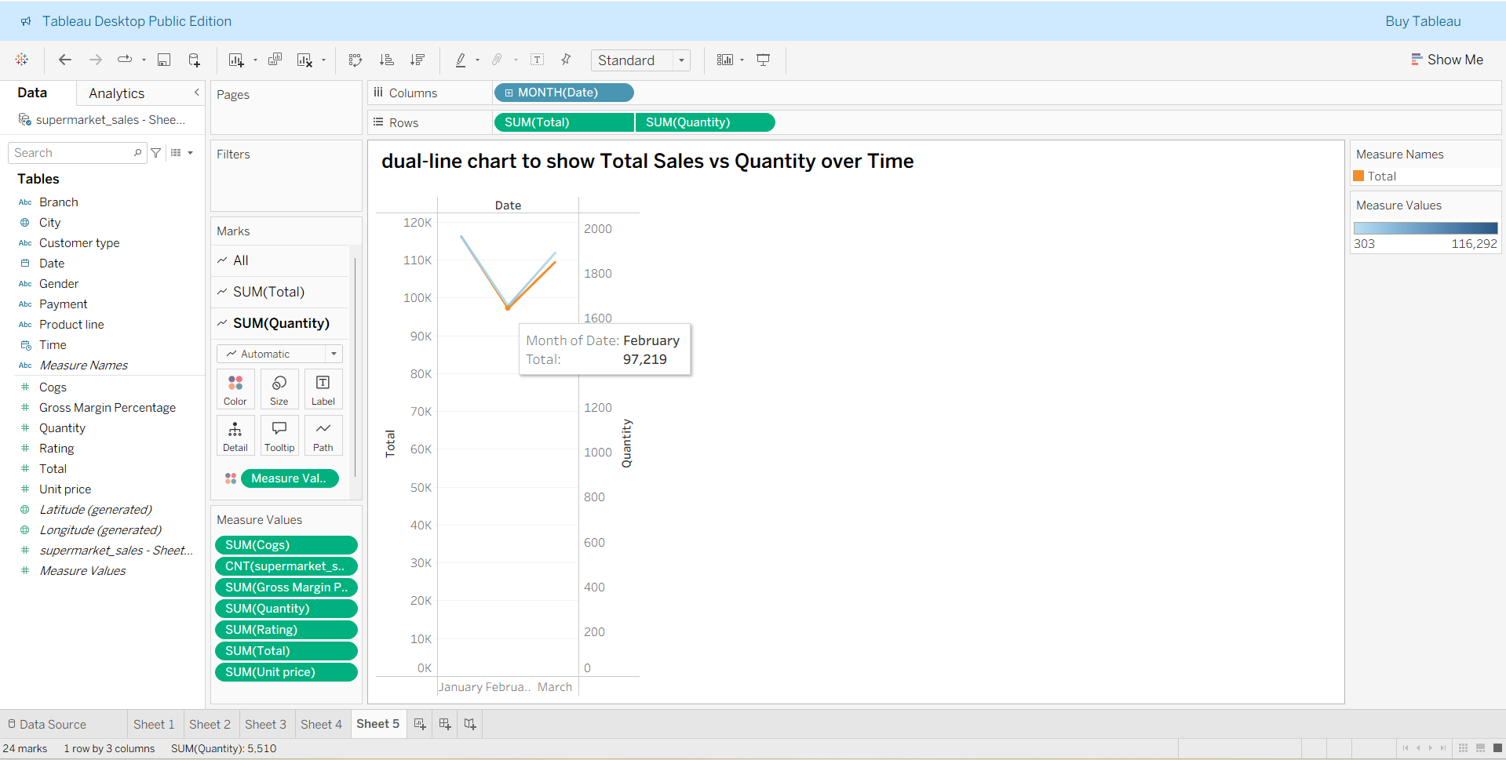

**Dashboard**

Submitted by :

Tupakula Shaik Sameer

Roll Number : 22KP1A1256

Internship : Smart Bridge – Data Analytics with Tableau